MTH501 Linear Algebra
Final Term Examination - August 2004
Time Allowed: 150 Minutes

Instructions
1. The duration of this examination is 150 minutes.
2. This examination is closed book, closed notes, closed neighbors.
3. There are 12 questions and you have to answer all questions.
4. Do not ask any questions about the contents of this examination from anyone.
5. If you think that there is some mistake in any question then make the best possible
assumption and solve the question.

**WARNING: Please note that Virtual University takes serious note of unfair means. Anyone found involved in cheating will be awarded grad `F` in this course.

Total Marks: 60 Total Questions: 12

Question No. 1 Marks : 5

Find the bases for the row and column spaces of
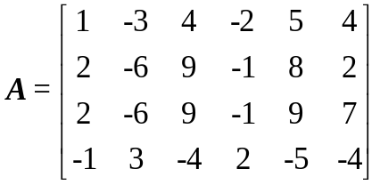

Question No. 2 Marks : 5

Suppose that B = {b1, b2} is a basis for V and C = {c1, c2, c3} is a basis for W. Let be a linear transformation with the property that
Find the matrix M for T relative to B and C.

Question No. 3 Marks : 5

Use the factorization A=QR to find the least-squares solution of Ax = b.
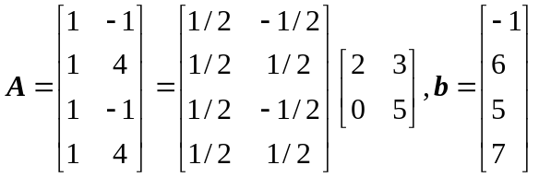

Question No. 4 Marks : 5

Verify that 1k, (-2)k and 3k are linearly independent signals.

Question No. 5 Marks : 5

Let T: P2P3 be the transformation that maps a polynomial p (t) into the polynomial (t + 5) p (t).
Find the matrix for T relative to the bases {1, t, t2} and {1, t, t2, t3}.

Question No. 6 Marks : 5

Find the inverse of the block diagonal matrix A, where
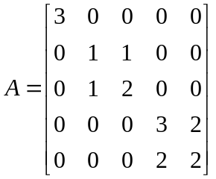

Question No. 7 Marks : 5

Each of the following equations determines a plane in R3. Do the two planes intersect? If so, describe their intersection.
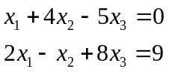

Question No. 8 Marks : 5

Determine if the following matrix is diagonalizable.
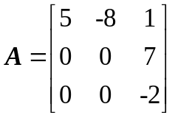

Question No. 9 Marks : 5

Let
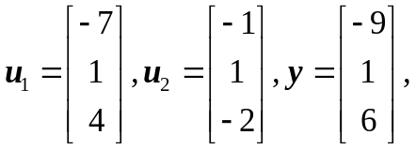
and
W = Span{u1, u2}.
Use the fact that u1 and u2 are orthogonal to compute projwy.

Question No. 10 Marks : 5

Let
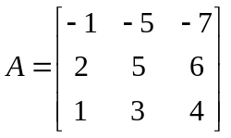
Find the third column of A-1 without computing the other columns.

Question No. 11 Marks : 5

Let
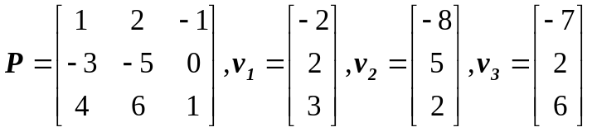
Find a basis {u1, u2, u3} for R3 such that P is the change-of-coordinates matrix from {u1, u2, u3} to the basis {v1, v2, v3}.

Question No. 12 Marks : 5

Let
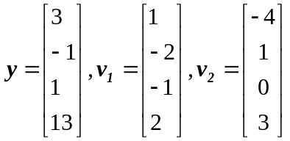
Find the distance from y to the subspace of R4 spanned by v1 and v2.

